[cover sheet]

3

ASSIGNMENT 3

**CYCLOMATIC COMPLEXITY, PHASE 1**

CSE 6329 -- SOFTWARE MEASUREMENT AND QUALITY ENGINEERING

Professor Dennis J. Frailey

**Fall, 2017**

|  |  |
| --- | --- |
| NAME | STUDENT ID NUMBER |
| **Ridham Kothari** | **1001446086** |

|  |  |  |  |  |  |  |
| --- | --- | --- | --- | --- | --- | --- |
|  | | **Cyclomatic Complexity Calculation** | | | | |
| **Program** | **Arcs** | | **Nodes** | **C (Number of Separate Flowgraphs)** | **Arcs - Nodes** | **Arcs – Nodes + 2C (Cyclomatic Complexity)** |
| Main | 27 | | 25 | 1 | 2 | 4 |
| Function | 110 | | 88 | 1 | 22 | 24 |

|  |  |  |  |  |
| --- | --- | --- | --- | --- |
| **Grading Comments (student – do not write inside this box)** | | | | |
| **Phase 1** | | | | |
| **<total goes here>** | **/10** | **Flowgraph (m)** | | **Comments from Grader** |
| **/5** | **Complexity (m)** | |
| **/10** | **Program (f)** | |
| **/10** | **Flowgraph (f)** | |
| **/ 5** | **Complexity (f)** | |
| **Phase 2** | | | | |
| **<total goes here>** | **<name>** | | First Program Reviewed | |
| **/ 5** | | **Errors** |  |
| **/ 5** | | **Cyclomatic Complexity** |
| **/ 10** | | **Flowgraph** |
| **<total goes here>** | **<name>** | | Second Program Reviewed | |
| **/ 5** | | **Errors** |  |
| **/ 5** | | **Cyclomatic Complexity** |
| **/ 10** | | **Flowgraph** |
| **<total goes here>** | **<name>** | | Third Program Reviewed | |
| **/ 5** | | **Errors** |  |
| **/ 5** | | **Cyclomatic Complexity** |
| **/ 10** | | **Flowgraph** |
| **<total>** | **Grand Total** | | |  |

**Place flowgraphs on next page(s)**

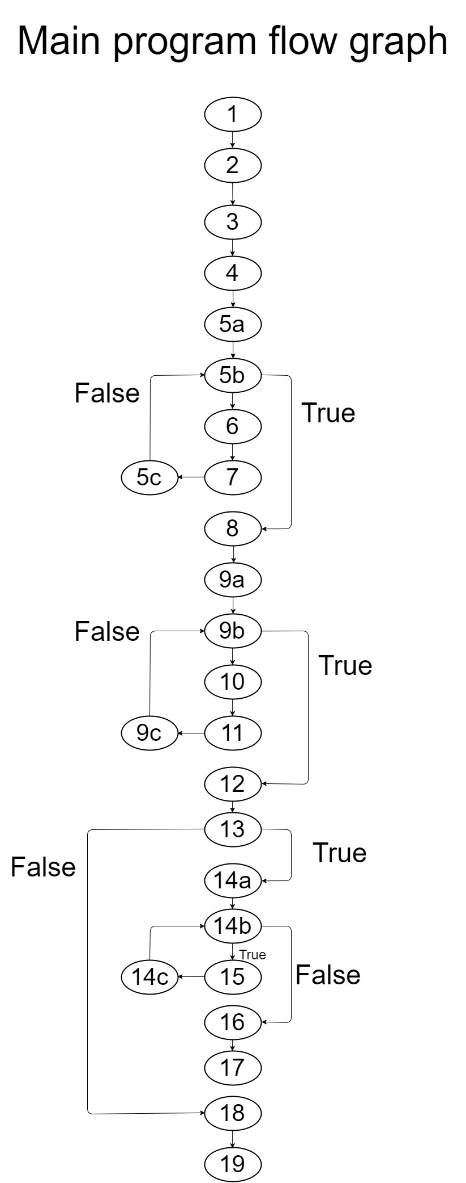

**Cyclomatic Complexity of Main Program:**

Number of Nodes: 27

Number of Arcs(edges): 25

Cyclomatic Complexity = e – n + 2c

= 27 – 25 + 2 (1)

= 4

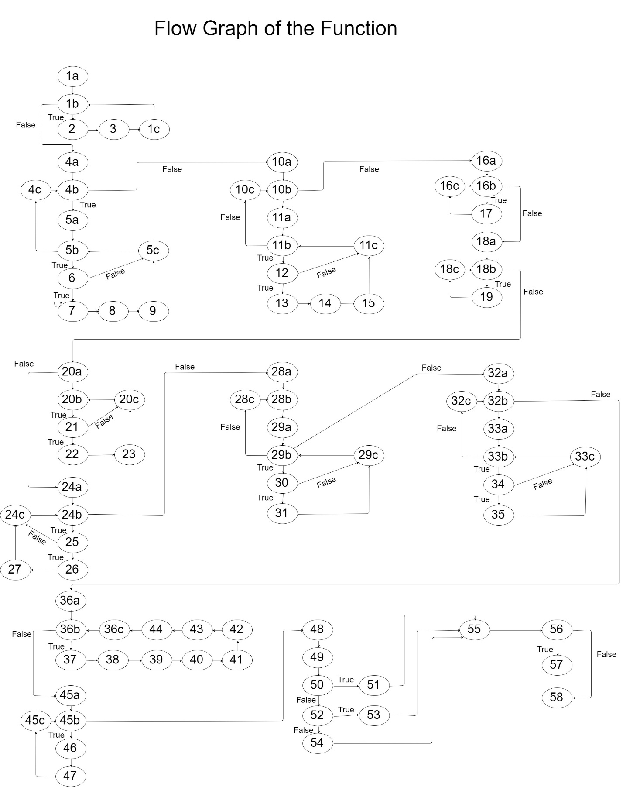

**Cyclomatic Complexity of Main Program:**

Number of Nodes: 110

Number of Arcs(edges): 88

Cyclomatic Complexity = e – n + 2c

= 110 – 88 + 2 (1)

= 24